

**QA Engineer – Assignment**

INSTRUCTIONS: Answer all questions. Expand the sections accordingly to insert your answers.

1. Explain test plan and test strategy difference.

| ****Test Plan**** | ****Test Strategy**** |
| --- | --- |
| A test plan describes in detail of testing scope and the activities involved during testing. | A test strategy is a high-level document contains guidelines the way testing will be conducted. |
| A test plan is project specific. | A test strategy is more generalize and is usually for a complete organization usage. |
| It describes the overall testing activities in detail like the techniques used, schedule, resources, etc. | It describes in high-level on test design techniques to be used, environment specifications, etc. |
| It is prepared by test lead or test manager. | It is usually prepared by the project manager. |
| A test plan document includes components like – features to be tested, components not to be tested, testing approach, pass-fail criteria, testing deliverables, estimation, assumption, etc. | A test strategy document includes – scope, testing approach, testing tools, test environment specification, release control, risk analysis, etc. |
| Test plan can be changed or updated. | Test strategy is seldom changed. |
| It is about the details and specific. | It is more about general approaches and methodologies. |

1. What fields do you need to define before you start writing test cases? (ex. Test Case ID)

Test case ID,Test case description, Test case module, Test case data/parameter used, Test case steps, Expected result,Current result, pass or fail test case, execution date, executed by, remarks

1. Please write the test cases for the below application.

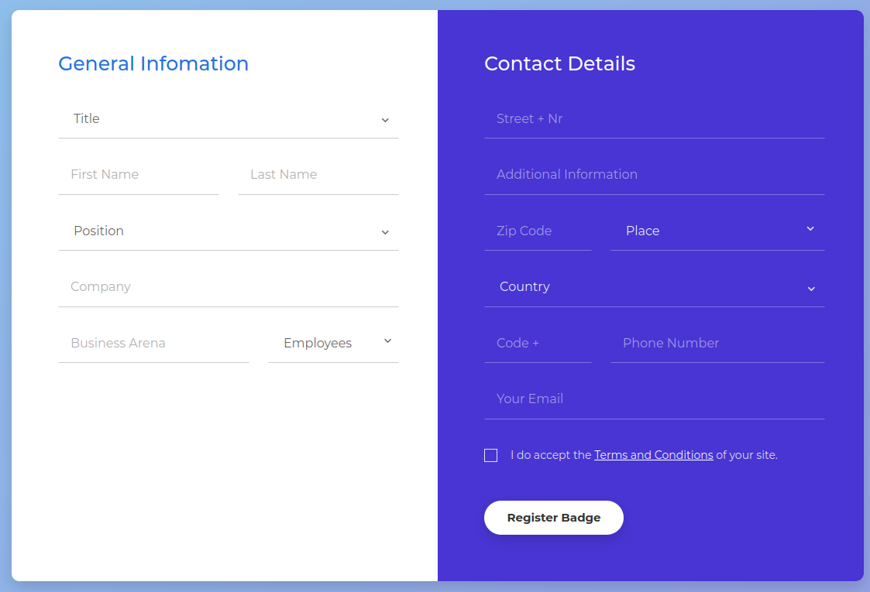

1. A part of the above application can utilize automation script. Please share where and why.

Registration Badge process can be utilize for automation script. This is because the data need to be filled in is static and the process of registration badge is following same process flow. It can be repeatable.

1. Choose **ONE** and provide your answer,
   1. write the automation script (per Q4) using Python or Java
   2. provide specific technical details how you would go through this test activity (step by step process)

5B. **STEP 1 : Identifying the automation tool to be used**

When identifying the automation tool to be used, there are few criteria to be

considered including ;

1. suitable to the automation testing you would like to do test (ex: mainframe testing you may use Macro embedded in Excel or QTP, website testing you may use Sellenium), performance testing you may use Postman.
2. Budget - if your company do not have much budget then try freeware such as Postman.
3. Time - complexity to automate the testing and coding required
4. Can be support or configured to your device (ex: If you have installed Windows 10, make sure the software is not compatible to it and able to used with Windows 2000.

**STEP 2 : Download the tool from link**

Install the tool to your system

**STEP 3 : Record to Create a Test Case**

There are different ways for recording a test case depends on which software tools you select. Ex : I select TestingWhiz as my software tool

1. Select recording - launch the tool on your system and select option Recording to record the test case that you want to test
2. Open the Form URL - input the URL of the web form that you want to record for testing. Make sure you have cleared the cache cache or cookies of URL before initiate recording so that no issues or discrepancies during test execution process
3. Record Test Case - once the form has been loaded,hit Record button and fill up the form to record the inherent steps
4. Stop Recording - on submission of the form completed,hit Record button again to stop recording
5. Save Test Case - next, the test script will appear in the main editor in a big list. Click on File menu and save test case for playback in later stage

**STEP 4 : Run Test Script**

1. Open the Save test script-open the saved test script whenever you wish to do

automated testing

1. Playback test script-hit play button to execute the test script on default

browse. There is also choice for selecting other browser to run the test script

1. Verify the result - verify the result is as per expected